Can a group of ordinary people come together to find better health solutions? Would you like to explore genomic data, biophysical data, and personalized interventions to find what works best for you, optimize your physical and mental performance, and be part of the citizen science community to help answer these questions?

Memory Filtering Study  Determine if genetic variants in the dopamine pathway impact how rapidly you adapt to ongoing reality in the first international citizen science collaboration with University Hospitals Geneva, Switzerland |  |  |  | Retin-A Acne/Wrinkles Study  Investigate if possible skin irritation from Retin-A (tretinoin) products can be predicted ahead of time from personal genomic profiles |  | 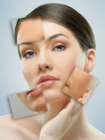
Requirements: Perform memory filtering exercise, background survey (approx 40 min) |  |  |  | Requirements: Complete online survey regarding Retin-A skin care product experience (approx 10 min)
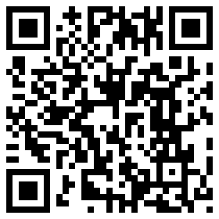 | Participate: http://bit.ly/memory-filtering-study |  |  | 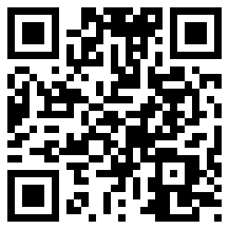 | Participate: http://bit.ly/retin-a-study

TA-65 Aging Study |  |  | Vitamin D Study |  |  | Vitamin B Study
Determine efficacy of TA-65 telomerase activation therapy  Requirements: Telomere length measurement and TA-65 therapy |  |  | Investigate genetics, Vitamin D deficiency, and supplementation  Requirements: Vitamin D blood tests, Vitamin D supplements |  |  | Explore genetics, homocysteine, and personalized intervention  Requirements: Homocysteine blood tests, Vitamin B vitamins
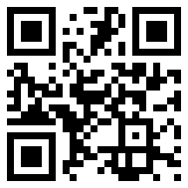 | Participate: http://bit.ly/mAkLbo |  | 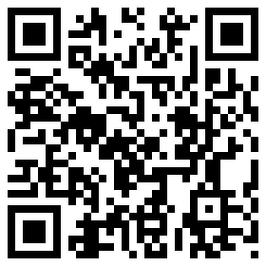 | Participate: http://bit.ly/kb5R1l |  | 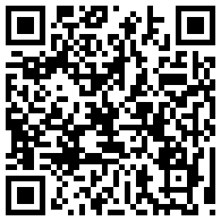 | Participate: http://bit.ly/mseecQ

SIGN UP FOR THESE STUDIES NOW! http://www.DIYgenomics.org

